Self Evaluation:

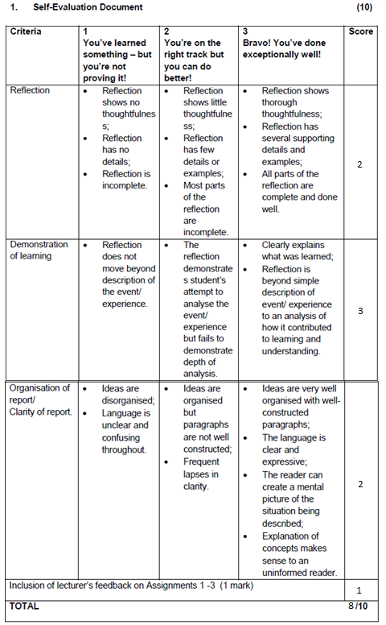

Reflection:

I reflected all work that I have l learned throughout this year in my final PROG6212 POE assignment. I have shown thoughtfulness in this assignment in the windows form, through the flow of the program, to the features it has shown, as well as the execution of the key functions of the form. In the web, I have thought about the amount of information placed on there, and feedback that will be received by the users. In the mobile app, I made sure the physician had a few options but that it performs the main function without a problem. Throughout all the assignments, I have linked them all to a central database, that updates information, whenever something is changed on any of them, and it will then update the rest.

Demonstration of Learning:

I have made excellent demonstration of what have been learned throughout this year in my course, as well as in extra research that was done. I have executed the work well, and showed that I have gone the extra mile in showing what I have learned. Not only in the programming or flow of the program, but as well in design and feedback, paying attention to everything, including the users experience.

Organisation of report/clarity of report:

All ideas are well organised and recorded. The language used is simple and understandable by everyone, not just relying on technical terms to discuss the reports on what is happening. When reading the report, it will be guided by pictures, which really help with explanation on what to do, or what can be done. The documentation really helps the users along, and made the program easy to use and understand at first time use.